**Student Questions**

Learn about the internals of a standard PC case by examining physical samples and selecting and labeling images found on-line. Gain deeper knowledge by researching and reporting on specific components.

PC Tower Case

1. Find one (or more) images that clearly show the internals of a PC Tower Case.   
   (i.e. Google images using keywords “PC Case Internals”)

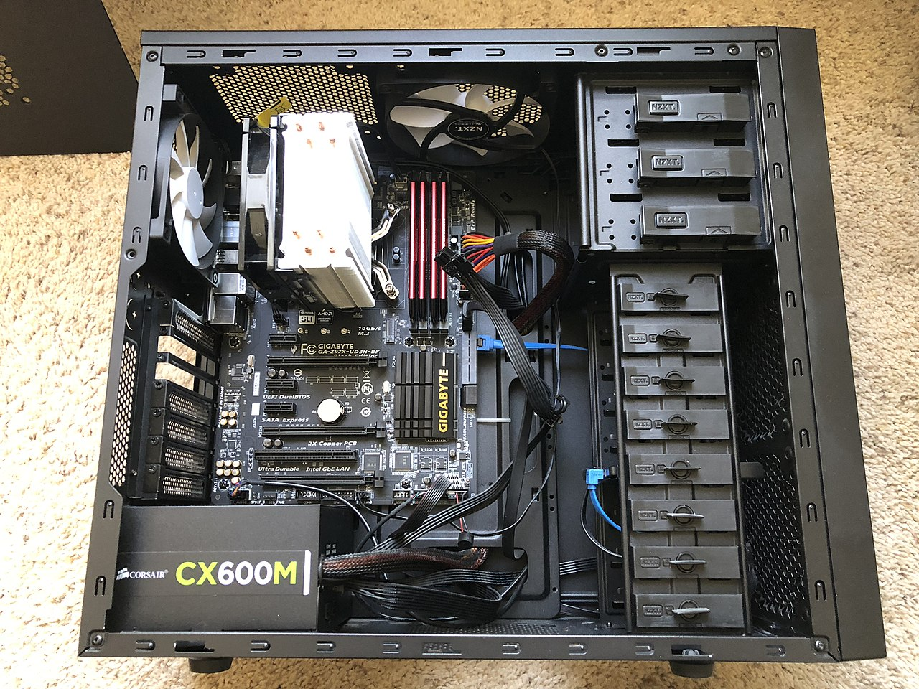

Monitor Port

Audio Ports

Disk Hard Drive

USB Expansion Port

Ethernet Port

Optic Disk Drive

Cooling Fan

Motherboard

Power Supply

1. Clearly label the following components (using arrows) on your image of the PC case internals:
   1. Motherboard
   2. Power Supply
   3. Hard Disk Drive
   4. Optical Disk Drive (e.g.DVD)
   5. USB Expansion Ports
   6. Monitor Port
   7. Audio Ports
   8. Ethernet Port
   9. Cooling Fan
2. Research more in-depth about “Hard Disk Drives”. Make notes on the following:
   1. What different versions are currently available (speed and capacity)?

There are a lot of different hard drive drives but the most common ones are 2.5 and 3.5 inch drives. The 3.5 inch are used in computers and the 2.5 inch are used in laptops.

* 1. How the capacity of the component has changed since the 1980s?

In 1800, hard drive disks were 5.25 inches in diameter, and could hold 5 MB of data. It costed $1500 and it was designed to fit into personal computers of the day. Now, the hard drive disks are 3.5 inches in diameter, and they typically hold 1 TB of storage and they cost about $50.00.

PC Motherboard

1. 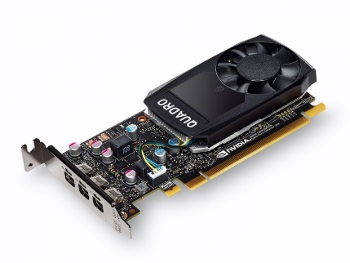Find one (or more) images that clearly show the layout of a PC Motherboard.   
   (i.e. Google images using keywords “PC Motherboard”)  
     
   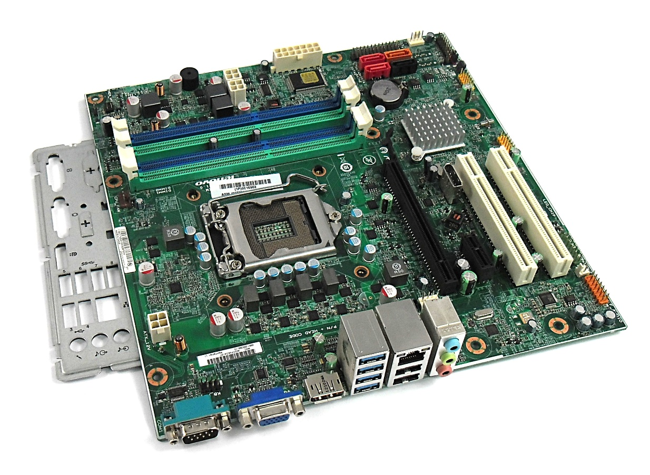 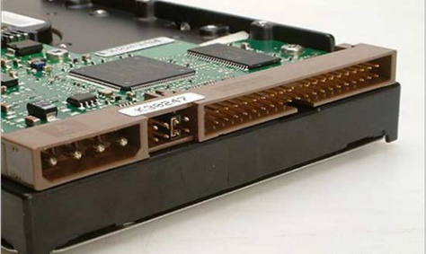 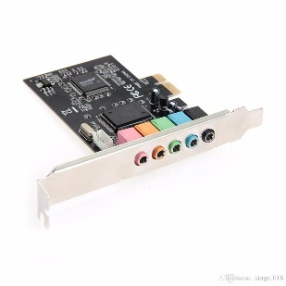

Sound Card

D.D.I

RAM Memory

CPU

Wi-Fi

1. Clearly label the following components (using arrows) on your image of the PC motherboard:

Graphics Card

* 1. CPU (and fan)
  2. RAM Memory
  3. Disk Drive Interface (IDE or SATA)
  4. GPU Graphics Processor (either on-board or Graphics Card)
  5. Sound Processor (either on-board or Sound Card)
  6. Wi-Fi / Ethernet Network Interface (either on-board or Graphics Card)

1. Research more in-depth about “CPU Processor Chip”. Make notes on the following:
2. What different versions are currently available (speed and capacity)

Since 2009, there has been a total of seven different CPU processing chips including Intel Pentium, Intel Core, Intel Core 2, Intel Core i3, Intel Core i5, Intel Core I7, Intel Core i1 (Extreme), Intel Core i9, Intel Core i9, and Intel Core i9 (extreme)

1. How the speed of the component has changed since the 1980’s

In 1971, the processing chip’s bus speed was 400 MHz, 533 MHz. Now, the processing chip’s bus speed is 1066 MHz, 1600 MHz.

Peripheral Devices

1. 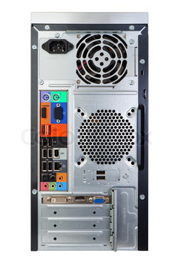Find one (or more) images that clearly show the layout of the back of a typical PC tower case.   
   (i.e. Google images using keywords “Back Of PC Tower”)

Ethernet Interface

Monitor Inerface

Keyboard Interface

USB Ports

Audio Input

Power Cord

1. Clearly label the following components (using arrows) on your image of the back of a typical PC tower case:
   1. Power cord and power switch
   2. Monitor Interface (VGA or DVI or HDMI)
   3. Mouse Interface (USB or PS/2)
   4. Keyboard Interface (USB or PS/2)
   5. USB Ports
   6. Audio Inputs / Outputs
   7. Ethernet Interface

1. Research more in-depth about “External Portable Storage”. Make notes on the following:
2. Floppy Disks

Used to move information. About 3½ inches.

Used in older devices Stores about 1.44 mb of data

Created in 1869 Zip Drive and Jaz Drive are well known

1. CD-ROM / DVD / Recordable CD/DVD

DVDs can store up to 17.1 gb There are five different types of DVDs

DVDs hold six times that of a CD DVDs are used for videos and CD is used for audio

1. USB Memory Drives

Can hold up to two TB Used for holding large software

Can be used to hold videogames Can hold any type of data

1. Compact Flash Memory

They can be encrypted Most USBs weigh less than 30 grams

Typically hold 8 gb Can store any type of data

1. Cloud Based Storage  
   Can be accessed anywhere Well-known companies use them

The cloud is safe There are multiple formats of cloud access

**Presentation Outline**

Explore the development and features of a specific PC hardware component through deeper research and investigation. Work in partners to create a short presentation. Deliver the presentation to the class.

Each group will research a unique PC hardware component. Your specific topic will be assigned from the list provided below.

**Presentation Structure**

1. Explain what the PC component does and how it fits together with other components to make up a fully functioning PC.
2. Explain how the PC component works. Provide a diagram (image) showing the main parts of the component.
3. Research the current state of the art of the component in terms speed, capacity (size), and other related factors.
4. Research on-line suppliers that sell the PC Component. List the specifications for the available products and the cost (price).
5. Research how the PC component has changed and evolved since the early days of PCs in the 1980’s. Cover each of the following topics separately:
   1. Component Speed
   2. Component Size / Capacity
   3. Two other specifications specific to the PC component (ask Mr. Nestor)

**PC Component Topics**

|  |  |  |
| --- | --- | --- |
| **Topic** | **Partner 1** | **Partner 2** |
| CPU Microprocessor Chip |  |  |
| Motherboard Layout |  |  |
| Computer Graphics |  |  |
| Sound & Audio |  |  |
| Hard Disk Drives |  |  |
| Removable Disk Storage |  |  |
| Ethernet / Fiber Connectivity |  |  |
| Wifi / Bluetooth Connectivity |  |  |
| Mouse / Pointing Devices |  |  |
| Monitor & Display Technology |  |  |
| Printers & Output Technology |  |  |